**Program 4:**

Design and implement C/C++ program to find shortest path from a given vertex in a weighted connected graph to other vertices using Dijkstra’s algorithm.

**Algorithm:**

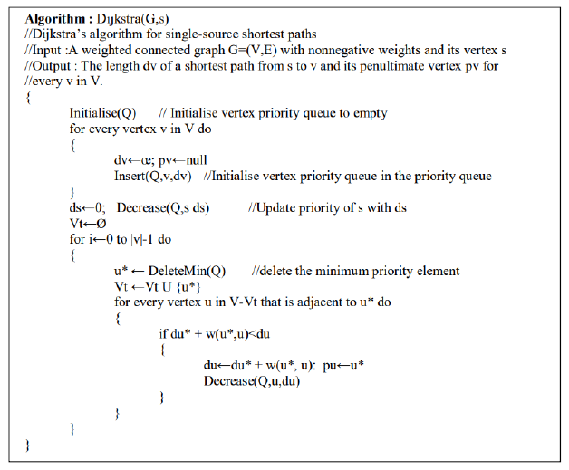

**Code:**

#include<stdio.h>

int cost[10][10],n,dist[10];

int minm(int m, int n)

{

return((m<n)?m:n);

}

void dijkstra(int source)

{

int s[10]={0};

int min, w=0;

for(int i=0;i<n;i++)

dist[i]=cost[source][i];

dist[source]=0;

s[source]=1;

for(int i=0;i<n-1;i++)

{

min=999;

for(int j=0;j<n;j++)

{

if((s[j]==0)&&(min>dist[j]))

{

min=dist[j];

w=j;

}

}

s[w]=1;

for(int v=0;v<n;v++)

{

if(s[v]==0&&cost[w][v]!=999)

{

dist[v]=minm(dist[v],dist[w]+cost[w][v]);

}

}

}

}

int main()

{

int source;

printf("Enter the number of vertices: ");

scanf("%d",&n);

printf("Enter the cost matrix \n");

for(int i=0;i<n;i++)

for(int j=0;j<n;j++)

scanf("%d",&cost[i][j]);

printf("Enter the source vertex: ");

scanf("%d",&source);

dijkstra(source);

printf("The shortest distance is: ");

for(int i=0;i<n;i++)

printf("Cost from %d to %d is %d\n",source,i,dist[i]);

}

**Output:**

